Journaling
Greenhouse Observations
My class is taking good care of the school greenhouse. Last month we cleaned the greenhouse. Students from another class helped us.
Retaj S.
We planted new herbs. I put lilies in the soil. Hawa put coffee on the plants to repel insects. Joeanette planted catnip. Denis planted onions in the soil. Hawa planted Mexican tarragon and zucchini. The plants drank water, and the teachers ate new herbs.
Julissa S.
We cut some plants. We cleaned the greenhouse. We watered the garden with a hose We planted different plants. Retaj took pictures. Denise threw coffee on the plants. Shadi fixed the black shading cloth around the greenhouse. Majdi watered the trees from a bucket. Xavier planted lettuce.
Fazili R.
Today everybody planted. We put plants in the soil. Shadi watered plants. Then we cut celery. Mwavita, Shemsa, and Hawa put plants in the bags to share with teachers.
D. Uwimana
We dug the soil in the square containers and planted. My friend and I planted thyme, bee balm and onions. Bashar planted a tree. Fazili took pictures in the greenhouse.
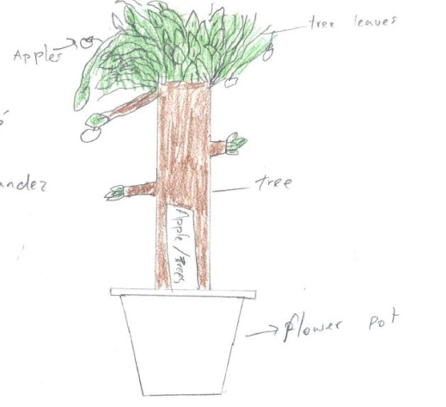
Mwavita R.
Lettuce is between basil and rosemary.
Hawa O.
Brayan planted tomatoes. Julissa planted flowers. Shadi and Miss Engel watered the plants. José, Madji, and Xavier planted an apple tree.
Mabeling C.C.
I clean the greenhouse every week.
Bashar J.
Now in the greenhouse, the plants are growing. Every day, we water the plants. Every week, we put the herbs into bags and share with Amphi community. Last month, I watered the plants, threw coffee on the plants to scare the bugs, separated herbs in bags, and sold them. Today, I chose a container to take care of. I drew my container and labeled my plants. I cleaned the container of yellow leaves, put the yellow leaves into compost, added new soil, and fed my plants. I need to decide if I want to plant more.
Joannette P. D.

Now a big bug is eating our plants, so Shemsa is throwing coffee dregs on plans. I put green beans into a bag.
José G. H.
My class visited the school greenhouse. I took a picture of strawberry. My strawberries look small. They are about 3-4 inches tall. A strawberry is a fruit. It is growing in box number 3. It develops fast because the soil is rich, the sun is good, and students water the plants every day. My prediction is that plant is going to bloom in 2 months.
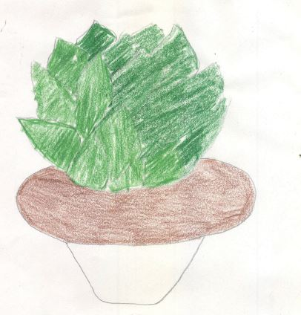
Francoise
My plant is an onion. I like my plant because it is good to eat.
Hawa
José is putting soil in the bucket.
Azzizah
Today everybody is working.
Sifa
On October 31, 2017, my class and I visited the school greenhouse. I took some pictures of potatoes. My potatoes look healthy. They are about 30 inches tall. A potato is a vegetable. It’s growing in box number 11. It develops fast because the soil is rich, the sun is bright, and students are watering plants every day. I predict that the potatoes will bloom in December. When it ripens, it will turn brown.
Bonheur
We put herbs into bags and share with Amphi Community.
Fazili
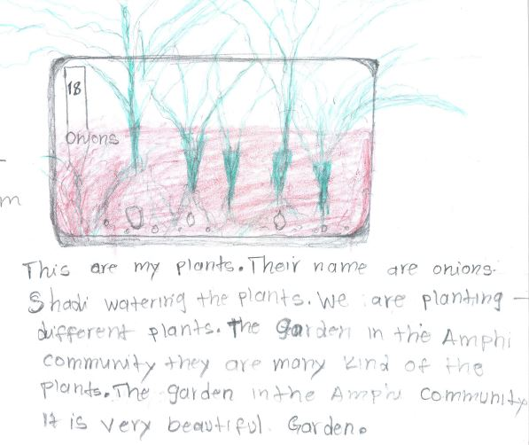
These are our greenhouse plants:
- potatoes
- tomatoes
- green beans
- sage
- garlic grass
- basil
- rosemary
- oregano
- tarragon
- sorrel
- onions
- asparagus
- artichoke
- squash
- zucchini
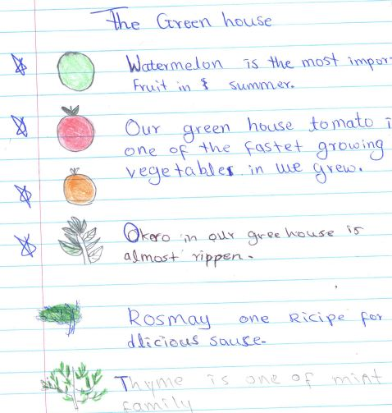
- lemon
- nectarine
- apples
- plum
- pear cactus (nopal)
Shemsa
My mom uses my plant to cook, and my sister Sara likes to cook my plant like that: first she puts water in the pot, and second, she adds some honey and oil. Sometimes my father likes to eat only thyme. When I told my father that I have a plant in the greenhouse, my father said, “Good job, Mwavita!” My family loves to eat thyme. I think you will feel strong if you eat the plants.
Mwavita
In my family they use potato, beans, and vegetables. Carrots, broccoli, kale, cabbage. Potato and cabbage are the best food in my family. Mom cooks potatoes and broccoli at dinner. My favorite food is potatoes and cassava is very important in my life and my family.
Raul Rubio
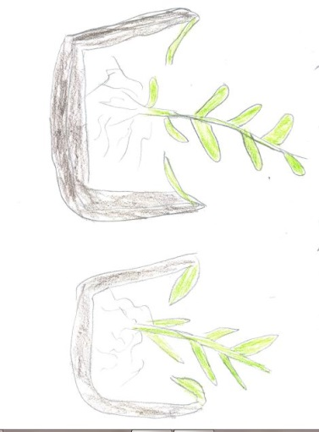

On October 31, 2017, my class visited the school greenhouse. I took a picture of tomatoes. My tomatoes look fantastic and beautiful. They are about 22 inches tall. Tomatoes are good vegetables. I am growing a vegetable in box number two. It develops fast because the soil is rich, the sun is shining, and the students water the plants every day. My prediction is that the plant is going to turn red because right now the tomatoes are all green. When the tomatoes ripen they will turn ted, and then we can eat them.
Christian M.

Family Recipes
Onion and Tomatoes Recipe
- Peel the onion and tomatoes.
- Put cooking oil in a saucepan.
- Cut the onions and tomatoes.
- Then put into the saucepan when the cooking oil is ready and well heated by fire.
- Stir and put some salt in it.
Mashed Potatoes Recipe
- Peel potatoes.
- Boil potatoes for 10 min.
- Pour out the water.
- Mash potatoes.
- Add salt and milk.
Christian M.
Last month, we planted tomatoes and beans in the greenhouse. I saw my beautiful flowers, I put water on the flowers and cut the flowers. Today I planted apples and tulips, saw my beautiful flowers, put water, put the tree in the box, and cleaned my flowers. Bashar planted trees and poured water on the trees.
Xavier S.

Green Beans
- First you have to put them in water and clean them.
- Remove beans from the water and put some in dry place.
- Get saucepan put it on a stove and put green beans in the boiled water.
- Put in cooking oil to be heated by fire.
- Slice tomatoes and onions.
- Put them in pan with green beans and leave four minutes to get ready.
- Put it on the plate to eat.
Christian M.
Green Beans with Carrots and Potatoes
Ingredients:
1 cup extra virgin olive oil
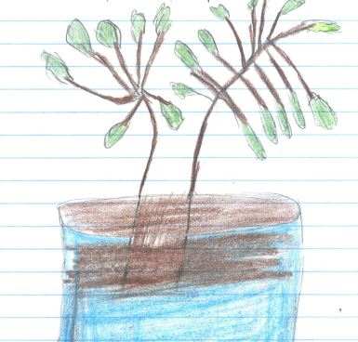
1 cup onions; shredded
1 cup parsley; chopped
Carrots; cut in thin rings
1 pound green beans (fresh or frozen)
4 potatoes; cubed
Fresh tomatoes; grated
Salt and pepper to taste
2 cups of water
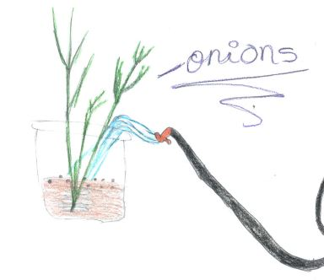
Instructions:
- Heat olive oil in a pot. Add onions and sauté for 2 minutes. Add parsley, carrots, beans, and potatoes. Mix well.
- Add salt, pepper, tomatoes, and water. Simmer for 40 minutes.
Azzizah

How to Make Rice
- 2 cups of rice
- 1 cup of oil
- 2 tablespoons of salt
- 3 cups of water

Put everything in the dish and then mix together. It is very good rice.
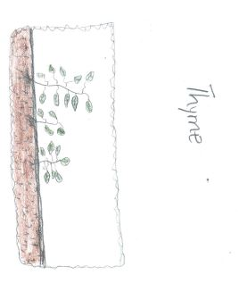
Abdin

Mashed Potatoes
- Put the potatoes in hot water for 16 min.
- Mash the potatoes.
- Put cheese, bacon, and onions.
- Finish…delicious.
Joa
How to Make Zigni
- Chop 2 onions.
- Fry the onions.
- Add chilli after frying the onion for 3-5 minutes.
- Add sauce.
- Put chicken after the sauce cooked for 5 minutes.
- Finally, add boiled eggs as much as you could after the chicken is cooked.
Zahra A.

Boiled Potatoes with Herbs
- Put potatoes in water for 15 min.
- Put oregano.
- Put tomato.
- Turn off the stove.
- And it is ready. It’s delicious!
Julissa S.

Tabouli

To make Tabouli, follow these steps:
Step one: take three medium tomatoes, one head of lettuce, half a bunch of green onions, two big lemons, and a bunch of parsley, and wash them.
Step two: Cut the tomatoes, lettuce, parsley, mint, and green onions into very small pieces.
Step three: Add some salt, lemon, and olive oil and stir well.
Finally, put the tabouli in a dish. Serve it and eat it.
Amal

How to Make a Fried Chicken Dish
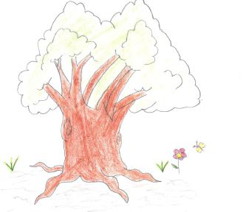
Ingredients:
- Chicken breast
- Olive oil
- Flour
- Egg
- Pepper
- Bread crumbs
- Potato and cheese
- Garlic
First step: Begin with the chicken breast and roll it in olive oil. Add the flour and raw egg.
Second step: Cover the chicken with bread crumbs. Fry the chicken on high heat for 8 minutes.
Third step: Cut the potato in the middle and add cheese. Then, spread the garlic sauce on it, and cook at a heat of 400 F º for 30 minutes. Enjoy with the chicken.
Yusef R.

Tomato Salsa

Ingredients:
- Tomatoes – 5
- Garlic – 1 or 2 teeth
- Oregano (to taste)
- Salt (to taste)
- Dry chile (whatever you want) (to taste)

Process:
First step: Boil the tomatoes or cook until the tomato is well cooked. The texture of the tomato must be soft.
Second step: Put the boiled tomato, garlic, oregano, salt, and the dry chile in the blender, and liquefy the mix.
Third step: Serve in a container and eat.
Jonathan D.
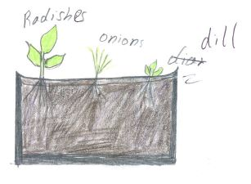
Recipe of a Salad

Ingredients:
½ a lettuce
3 tomatoes
½ of onion
2 avocados
3 pieces of broccoli
A table spoon of olive oilRanch dressing
A bunch of croutons
2 cucumbers
A piece of cheese
4 pieces of ham
A little of bacon

- Slice all the vegetables.
- Put all the vegetable in a big bowl.
- Add cheese, the bunch of croutons, the four pieces of ham, and then mix all together.
- After all, you will see a beautiful salad.
- If you have extra ingredients you want to add, add them to your taste.
Juan A.
Rice
You have to get rice and put rice in the saucepan.
Then, mix the boiled rice and onions in the saucepan.
Put the rice on the stove for a few minutes.
The water evaporates from the rice, and it gets dry.
Finally, prepare lemon juice and sauce. Then enjoy the rice.
Julita
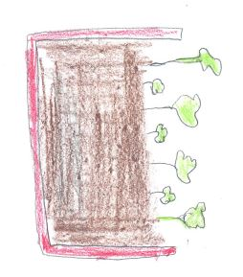
Green Beans

- First, cut the tails off the green beans.
- Third, cut the green beans in small pieces.
- Put the beans in a bowl, add water, and boil for ten or twenty minutes.
- When the water is finished, add some oil and onions.
- Add a little ginger, turmeric, garlic, black pepper, cumin seeds and fennel seeds.
- The beans will be ready in 15 minutes.
Zahid

