Mindset, Goals, Communication, Leadership and Financial Management

"Don't wish for less problems, wish for more skills" --Jim Rohn

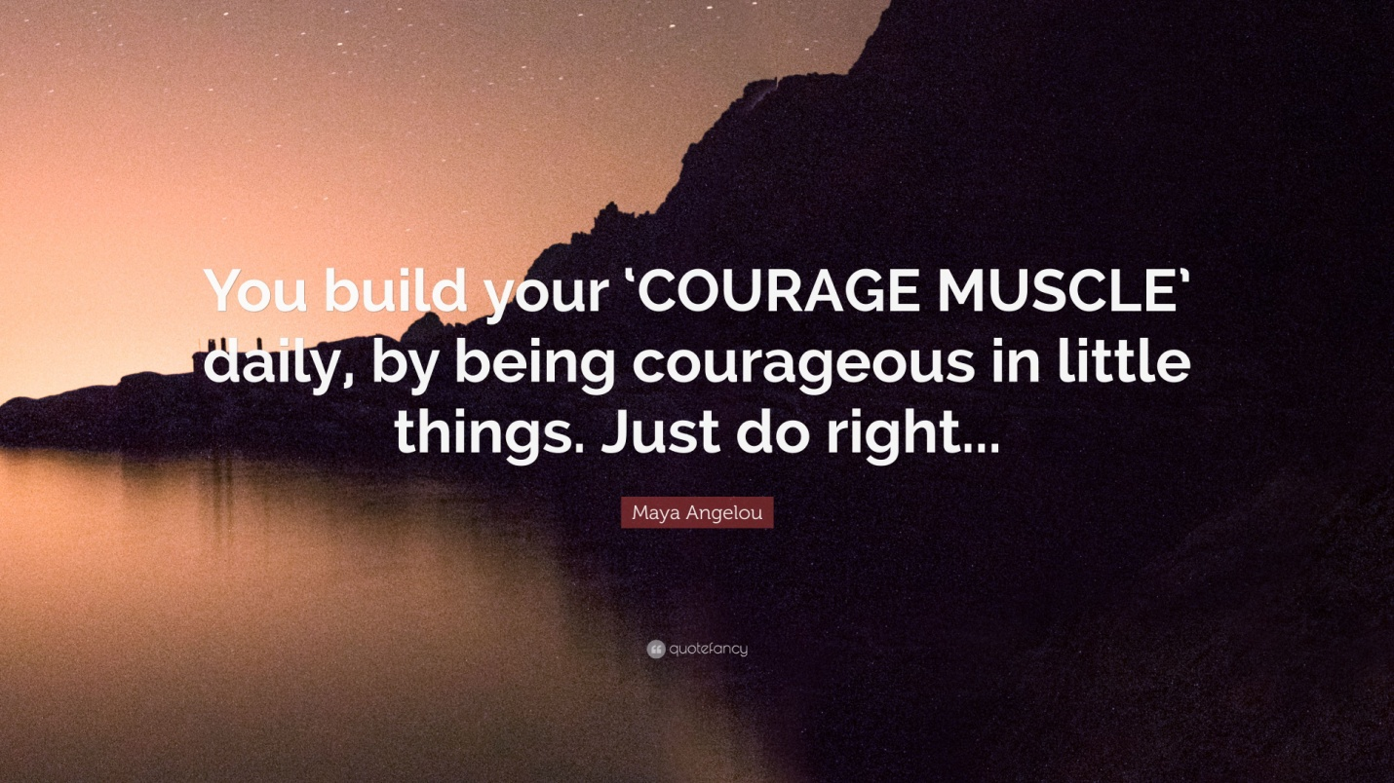

The future belongs to those with a clear sense of direction

Striving towards Greatness:
The Five Essential Elements of Success

I. Developing the Right Attitude and Mindset

II. Creating a Clear Vision and Direction for your Future

III. Understanding Financial Management

IV. Developing Good Communication and interpersonal Skills

V. Developing Leadership Skills

Table of Contents
Session I: The Power and Miracles of our Mind.
- Understanding where we are in life.
- Evaluate the power of the Mind and its Miracles.
- Analyzing how we could maximize our mind to our benefit.
- Evaluate the distinction between limiting and empowering beliefs.
- Understanding the driving forces behind all human behavior.
- Understanding the power of Gratitude
Final Assessment: Write a 2-3 page reflection on what mindset strategies you can apply to create a successful life.
Create a chart that aligns your values, beliefs and goal

Session II: Creating a Plan for a Compelling Future.
- Learn about the Importance of goal setting.
- Discovering your values and passions.
- Learn to maximize your passion to create a compelling future.
- The five step process of goal setting..
Final Assessment: Create a goal statement that reflects your short and long term objectives.
Create a vision board that highlights your personal, professional and social contributions for the future.

Session III: Understanding the power and importance of money.
- Why are some people more financially successful than others?
- Discovering your money blueprint.
- Understanding the secrets of financial freedom.
- Creating a new belief and plans for a successful financial future.
- Budgeting and its importance.
Final Assessment: Create a financial portfolio

Session IV: How to build a loving and lasting relationship with others.
- Discovering the importance of relationship.
- Learning the different means of communication.
- Learn to attract people to like you and building rapport.
- Learn to develop excellent communication skills.
- Understanding the techniques of Influence.
Final Assessment: Create a relationship vision statement.

Session V: Understanding Leadership and Influencing People.
- Understanding the difference between a manager and a leader.
- Discovering the 5 levels of leadership.
- Learning the techniques of the world's greatest leaders.
- Understanding the power of influence and how to maximize it.
Final Assessment: Based on what you have learned, draw a character and highlight the different qualities that you believe a great leader embodies.
Present your character to the class.

Youth Who Are Sad or Depressed in America
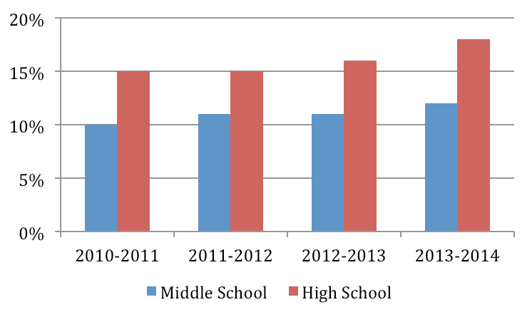

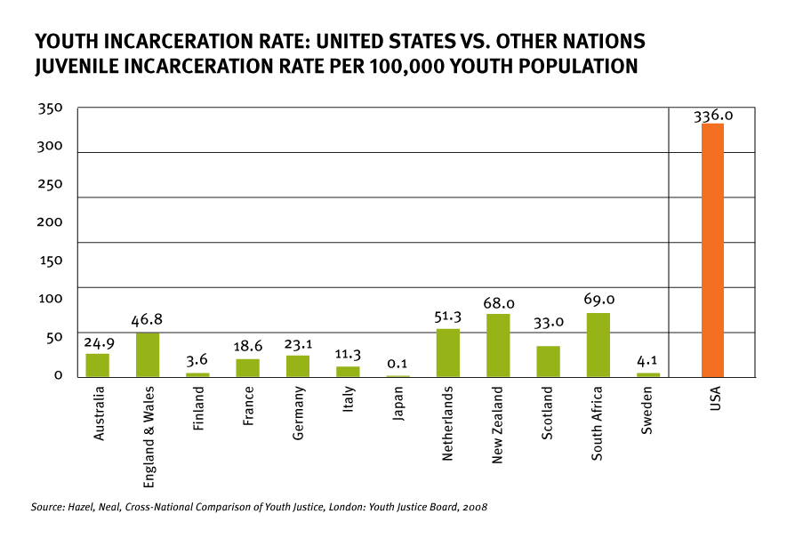

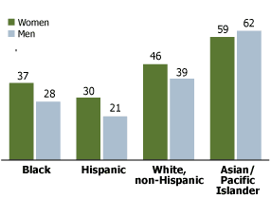

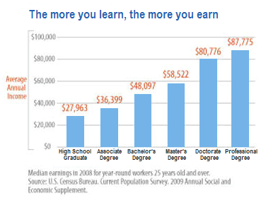

Uncovering Life's Precious Moments
1. You all of a sudden discovered that you're going to die in 12 hours, what would do? Who would you call? What you tell the person you called?
________________________________________________________________________________________________________________________________________________________________________________________________________________________________________________________________________________________________________________________________________________________________________

2. You're given $20 Billion, but you also have been diagnosed with a terminal illness with a 10 year prognosis. Explain how you would live the next ten years of your life.
________________________________________________________________________________________________________________________________________________________________________________________________________________________________________________________________________________________________________________________________________________________________________
________________________________________________________________________________________________________________________________________________________________________________________________________________________________________________________________________________________________________________________________________________________________________

3. What do these two scenarios help you to uncover about the things that are important to you? In other words, what is the lesson you learned?
________________________________________________________________________________________________________________________________________________________________________________________________________________________________________________________________________________________________________________________________________________________________________
________________________________________________________________________________________________________________________________________________________________________________________________________________________________________________________________________________________________________________________________________________________________________
The Two Master Skills
Aim_____________________________________________________________________________________

THE SCIENCE OF ACHIEVEMENT VS. THE ART OF FULFILLMENT

THE FOUR STEPS OF THE SCIENCE OF ACHIEVEMENT
I.__________________________________________________________________________________________________________________________________________________________________________________

II._________________________________________________________________________________________________________________________________________________________________________________

III.________________________________________________________________________________________________________________________________________________________________________________

IV.________________________________________________________________________________________________________________________________________________________________________________

WHAT IS THE ART OF FULFILLMENT?
__________________________________________________________________________________________________________________________________________________________________________________
__________________________________________________________________________________________________________________________________________________________________________________

REFLECTION: WHAT ARE YOUR YHOIUGHTS, COMMENTS OR QUESTIONS ABOUT THESE TW MASTER SKILLS
__________________________________________________________________________________________________________________________________________________________________________________
_____________________________________________________________________________________________________________________________________________________________________________________________________________________________________________________________________________
Conscious vs. Subconscious Mind

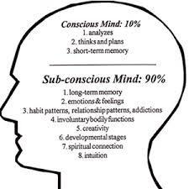

I. What is one limit of our subconscious mind?
_________________________________________________________________________________________________________________________________________________________________________________________________________________________________________________________

II. What controls our subconscious mind?
_________________________________________________________________________________________________________________________________________________________________________________________________________________________________________________________

III. How do we reprogram our subconscious mind for success?
_______________________________________________________________________________________________________________________________________________________________________________________________________________________________________________________________________________________________________________________________________________________________________________________________________________________________________________________________________________________________________________________________________________________________________________________________________________________________________________________________________________________
The Importance of Raising our Standards
Turning our Shoulds to Musts
Examine at least three areas of your life, what are shoulds and what are musts?
____________________________________________________________________________________________________________________________________________________________________________________________________________________________________________________________________________________________________________________________________________________________________________________________________________________________________

Limiting vs. Empowering
What is your limiting belief(s) in that area? | Turn your limiting beliefs into empowering beliefs

What rituals are going to support your empowering beliefs?
______________________________________________________________________________________________________________________________________________________________________________________________________________________________________________________________________________________

STARTING WITH WHY!

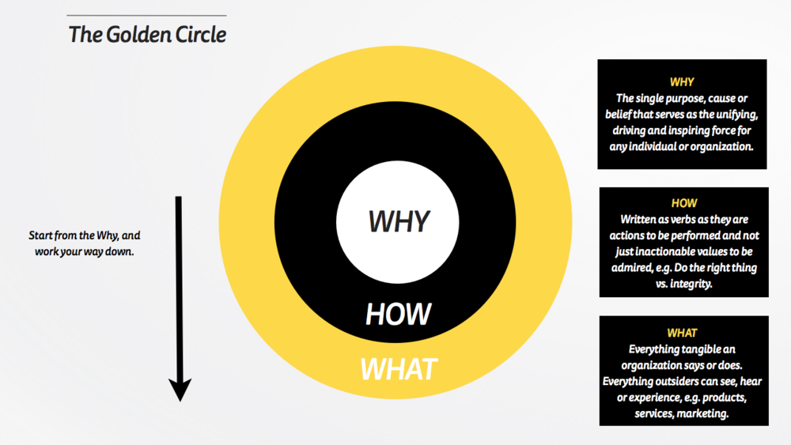

Why is it important to start with WHY?
________________________________________________________________________________________________________________________________________________________________________________________________________________________________________________________________________________________________________________________________________________________________________
_________________________________________________________________________________________

{Without vision, people perish}
"The person who knows their WHY can endure anyhow."
Summarize the meaning and explain the importance of this quote.
__________________________________________________________________________________________
____________________________________________________________________________________________________________________________________________________________________________________
II. GOALS, DREAMS, PASSION

Harvard Business School Goal Story

Study about goals at Harvard MBA program, 1979.
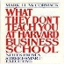
From the book What they don’t teach you at Harvard Business School by Mark McCormack:
In the book What They Don't Teach You in the Harvard Business School, Mark McCormack tells a study conducted on students in the 1979 Harvard MBA program. In that year, the students were asked, "Have you set clear, written goals for your future and made plans to accomplish them?" Only three percent of the graduates had written goals and plans; 13 percent had goals, but they were not in writing; and a whopping 84 percent had no specific goals at all.
Ten years later, the members of the class were interviewed again, and the findings, while somewhat predictable, were nonetheless astonishing. The 13 percent of the class who had goals were earning, on average, twice as much as the 84 percent who had no goals at all. And what about the three percent who had clear, written goals? They were earning, on average, ten times as much as the other 97 percent put together.
In spite of such proof of success, most people don't have clear, measurable, time-bounded goals that they work toward.
Why do you think people don't set goals that they could work towards?
_______________________________________________________________________________________________________________________________________________________________________________________________________________
Reasons most people don't set goals:
In the bestseller "Goals!", Brian Tracy teaches you how to identify in the clearest terms the things you want out of life, then how to make the plan to help you achieve those things. Brian Tracy says there are four reasons why people don't set goals:
- They don't realize about the importance of goals. If the people with whom you spend the most time — family, friends, colleagues, and so forth — are not clear and committed to goals, there is a chance that you will not be, either.
- They don't know how to set goals. Some set goals that are too general. These are, in reality, fantasies common to everyone. Goals, on the other hand, are clear, written, specific, and measurable.
- They fear failure. Failure hurts, but it is often necessary to experience failure in order to achieve the greatest success. Do not unconsciously sabotage yourself by not setting any goals in which you might fail.
5 STEPS OF GOAL SETTING
- 1. WHAT DO YOU WANT? BE SPECIFIC
- II. WHEN DO YOU WANT IT? EXACT DATE.
- III. WHAT ARE YOU WILLING TO GIVE UP OR OVERCOME TO ACHIEVE YOUR GOAL(S)?
- IV. CREATE AN ACTION PLAN AND IMPLEMENT IMMEDIATELY.
- V. WRITE IT DOWN IN A STATEMENT, AND READ TWICE A DAY.

Personal | Finance | Relationship | Health

- Goal Statement: In a paragraph, describe your ideal life...
- _______________________________________________________________________________________________________________________________________________________________________________________________________________________________________________________________________________________________________________________________________________________________________________________________________________________________
- _______________________________________________________________________________________________________________________________________________________________________________________________________________________________________________________________________________________________________________________________________________________________________________________________________________________________
- _______________________________________________________________________________________________________________________________________________________________________________________________________________________________________________________________________________________________________________________________________________________________________________________________________________________________
ACTION PLAN:
WHAT DO YOU NEED TO DO TO ACHIEVE YOUT GOALS?

Divide your goals into long term, medium term and short term:

Long term: More than a year
- _______________________________________________________________________________________________________________________________________________________________________________________________________________________________________________________________________________________________________________________________________________________________________________________________________________________________

Medium term: Six months to a year
- _________________________________________________________________________________________________________________________________________________________________________________________________________________________________________________________________________________________________________________________________________________________________________________________________________________________________________________________________________________________________________________________________________________________________________________________________________________________________________________________________________________________
- Short term: Less than six months
_______________________________________________________________________________________________________________________________________________________________________________________________________________________________________________________________________________________________________________________________________________________________________________________________________________________________________________________________________________________________________________________________________________________________________________________________________________________________________________________________________________________________________________________________________________________________________________________________________________________________________________________________________________________________________________________
Action Plan
Monthly Activities
________________________________________________________________________________________________________________________________________________________________________________________________________________________________________________________________________________________________________________________________________________________________________________________________________________________________________________________________________________________________________________________________________________________________________________________________________________________________________________________________________________________________________________________________________________
Weekly Activities
________________________________________________________________________________________________________________________________________________________________________________________________________________________________________________________________________________________________________________________________________________________________________________________________________________________________________________________________________________________________________________________________________________________________________________________________________________________________________________________________________________________________________________________________________________
Daily Activities
_________________________________________________________________________________________________________________________________________________________________________________________________________________________________________________________________________________________________________________________________________________________________________________________________________________________________________________________________________________________________________________________________________________________________________________________________________________________________________________________
BECOMING A CHARISMATIC PERSON
LAW OF ATTRACTION
Law of attraction is based on the concept that you attract people situations and issues based on the thoughts that you generate. Like magnet, we attract the conditions of our lives based on how we perceive our self and others.

I. Describe how you see yourself.
______________________________________________________________________________________________________________________________________________________________________________________________________________________________________________________________________________________________________________________________________________________________________________________________________________________________________________________________________________________________________________________________________________________________________________________________________________________________________________________________________________________________________________________________________________________________

Based on the way most people treat you, how do you think other people see you?
___________________________________________________________________________________________________________________________________________________________________________________________________________________________________________________________________________________________________________________________

How would you want other people to treat you? Describe in specific details how you would want others to treat you. ___________________________________________________________________________________________________________________________________________________________________________________________________________________________________________________________________________________________________________________________

Whatever qualities you describe above, how would you begin to develop those qualities first.
____________________________________________________________________________________________________________________________________________________________________________________________________________________________________________________________________________________________________________________________________________________________________________________________________________________________________

{Charisma is mostly about perception}
If you're about to meet a person and I told you, oh my God, the young lady you're about to meet graduated at the top of her class in high school and she is currently serves as the Student Body President at Harvard. What would you think of this person when you meet her?
__________________________________________________________________________________________________________________________________________________________________________________________________________________

What if I did not tell you any of these prior to meeting this young lady. What would you think of her when you meet her?
________________________________________________________________________________________________________________________________________________________________________________________________________________________________________________________________________________________________________________________________________________________________________________________________________________________________________________________________________________________________________________________________________________________________________________________________________________________________________________________________________________________________________________________________________________________________________________________________________________________________________________________________________________________________________________________________________________________________________________________________________________________________________________________________________________________________________________________________________________________________________________________________________________________________________________________________________________________________________________________________________________________________________________________________________________________________________________________________________________________________________________________________________________________________________________________________________________________________________________________________________________________________________________________________________________
________________________________________________________________________________________________________________________________________________________________________________________________________________________________________________________________________________________________________________________________________________________________________________________________________________________________________________________________________________________________________________________________________________________________________________________________________________________________________________________________________________________________________________________________________________________________________________________________________________________________________________________________________________________________________________________________________________________________________________________________________________________________________________________________________________________________________________________________________________________________________________________________________________________________________________________________________________________________________________________________________________________________________________________________________
TIME MANAGEMENT/SELF-MANAGEMENT

What is time?

Focus=Feeling
Feeling=Action

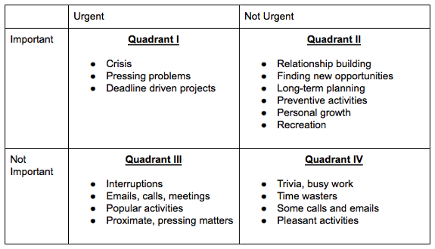
I. Which quadrant do you spend the most time in? Why?
______________________________________________________________________________________________________________________________________________________________________________________________________________________________________________________________________________

Which quadrant should you spend most of your time in other to maximize your tome? Why?
________________________________________________________________________________________________________________________________________________________________________________________________________________________________________________________________________________________________________________________________________________________________________
FEAR AND ITS DANGERS

In order to achieve success and live a life of excellence, we must answer these questions:
I. What stops us from moving forward? Taking action? Being our best?
II. What controls and determines the quality of our lives?
III. Why we do what we do? What is the ultimate drive behind all human action?

What lies before us, what lies behind us, is nothing compared to what lies within us.
RALPH WALDO EMERSON
I. WHAT STOPS US FROM MOVING FORWARD?
__________________________________________________________________________________________________________________________________________________________________________________________________________________
While we all experience countless variations, there are two primary fears that all human beings share:
I. We're not___________________________________________________________________________________________
II. We won't be _______________________________________________________________________________________

PROCESSING FEARS
1. WHAT IS YOUR GREATEST FEAR?
____________________________________________________________________________________________________________________________________________________________________________________

2. WHAT BENEFIT HAS THIS FEAR GIVEN YOU IN THE PAST?
____________________________________________________________________________________________________________________________________________________________________________________

3. WHY BE FREE OF THIS FEAR NOW?
_______________________________________________________________________________________________________________________________________________________________________________________________________________________________________________________________________________________________________________________________________________________________________________________________________________________________________________________________________________________________________________________________________________________________________________________________
FAITH: The Ultimate Resource
UNDERSTANDING THE SUCCESS CYCLE
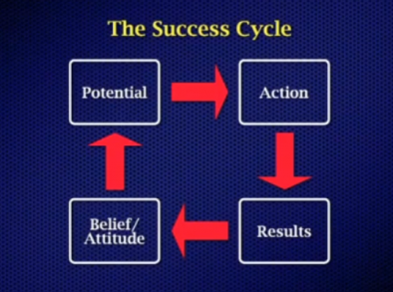

I. What is faith?
___________________________________________________________________________________________________________________________________________________________________________________________________________________________________________________________________________________________________________________________

II. What are three areas of your life that you need to have more faith in?
_____________________________________________________________________________________________________________________________________________________________________________________________________________________________________________________________________________________________________________________________________________________________________________________________________________________________________________________________________________________________________________________________________________

III. Explain why the rich get richer and the poor get poorer?
____________________________________________________________________________________________________________________________________________________________________________________________________________________________________________________________________________________________________________________________________________________________________________________________________________________________________

IV. How can you utilize the success cycle to maximize your life?
____________________________________________________________________________________________________________________________________________________________________________________________________________________________________________________________________________________________________________________________________________________________________________________________________________________________________________________________________________________________________________________________________________

DECISION SHAPES DESTINY

II. WHAT CONTROLS AND DETERMINES THE QUALITY OF OUR LIVES?
A. In every moment of our lives, we get to choose what to focus on.
B. Whatever we focus on, we have to give it a meaning.
C. Whatever meaning we give it, determines the kind of action we're going to take.
Exercise:
I. Focus_______________________________________________________________________________________________
II. Meaning___________________________________________________________________________________________
III. Action_____________________________________________________________________________________________

DECIDE, COMMIT, AND RESOLVE
1. What are two decisions you made in the past that have positively shaped your life? How did they change your life for the better? what finally got you to decide?
__________________________________________________________________________________________________________________________________________________________________________________________________________________________________________________________________________________________________________________________________________________________________________________________________________________________________________________________________
2. What are two new decisions you are committed to making now, and how will they powerfully improve your life forever?
________________________________________________________________________________________________________________________________________________________________________________________________________________________________________________________________________________________________________________________________________________________________________________________________________________________________________________________________________________________________________________________________________________________________________________________________________________________________________________________________________________________________________________________________________________
Three Decisions that Shape the Quality of our Lives
I. TRUTH
____________________________________________________________________________________________________________________________________________________________________________________

II. VISION
____________________________________________________________________________________________________________________________________________________________________________________

III. ACTION
____________________________________________________________________________________________________________________________________________________________________________________

EXERCISE
Select a current challenge and apply these three steps.
____________________________________________________________________________________________________________________________________________________________________________________________________________________________________________________________________________________________________________________________________________________________________________________________________________________________________________________________________________________________________________________________________________________________________________________________________________________________________________________________________________________________________________________________________________________________________________________________________________________________________________________________________________________________________________________________________________________________________________________________________________________________________________________________________________________________________________________________________________________________________________________________________________________________________________________________________________________________________________
III. UNDERSTANDING THE PSYCHOLOGY, EMOTION AND THE IMPORTANCE OF MONEY

Your personal beliefs about money:
Circle the ones you belief are true:
1. MONEY is the root of all evil.

2. Selfishness is a vice.

3. Lottery is the way to get rich quickly.

4. The road to riches is paved with formal education.

5. The best days to get rich happened in the past.

6. Because people need to pay their bills, they have work at jobs they don't like because that's all they have.

7. You should set low expectations so you never get disappointed.

8. You have to DO something to get rich.

9. You need money to make money.

10. The markets are driven by logic and strategy.

11. Because of the economy, people have to live beyond their means.

12. The most important thing about money is survival.
13. Having money causes stress.

14. Average people would rather be entertained than educated.

15. You should only surround yourself with likeminded people.

16. The best way to get rich is to save your money.

17. You should never take risks with your money.

18. Money cannot make you comfortable.

19. Money cannot make you healthy.

20. You must choose between a great family and being rich.

RETHINKING OUR OLD BELIEFS
What are your new beliefs?
__________________________________________________________________________________________________________________________________________________________________________________________________________________________________________________________________________________________________________________________________________________________________________________________________________________________________________________________________________________________________________________________________________________________________________________________________________________________________________________________________________________________________________________________________________________________________________________________________________________________________________________________________________________________________________________________________________________________________________________________________________________________________________________________________________________________________________________________________________________________________________________________________________________

Time vs. Value: What Do We Get Paid For?

1. What do we get paid on, according to Jim Rohn?

2. In order to increase your value, what do you need to work on?

3. When you work hard on yourself, you could make a...

Reflection: Write a paragraph reflecting on Jim Rohn’s presentation. For example, do you agree or disagree with him?

Rich vs. Average Mentality
Direction: In his book, How the Rick Think, Steve Siebold compares the thought-process of the rich and the poor. Explain their meaning and analyze their significance

1. “Average people believe you have to DO something to get rich. Rich people believe you have to BE something to get rich.”

2. “Average people earn money doing things they don't love. Rich people follow their passion.”

3. “Average people love to be comfortable. Rich people find comfort in uncertainty.”

4. “Average people believe they must choose between a great family and being rich. Rich people know you can have it all.”

5. “Average people have a lottery mentality. Rich people have an action mentality.”
THE IMPORTANCE OF BUDGETING

WHAT IS A BUDGET?
____________________________________________________________________________________________________________________________________________________________________________________________________________________________________________________________________________________________________________________________________________________________________________________________________________________________________________________________________________________________________________________________________________________________

WHY IS BUDGETING IMPORTANT FOR FINANCIAL STABILITY AND SUCCESS?
____________________________________________________________________________________________________________________________________________________________________________________________________________________________________________________________________________________________________________________________________________________________________________________________________________________________________________________________________________________________________________________________________________________________
_________________SSS___________________________________________________________________________________________________________________________________________________________________________________________________________________________________________________________________________________________________________________________________________________________________________________________________________________________________________________________________________________________________________________________________________

HOW TO CREATE A BUDGET
You just accepted your first job and you’ll be earning a gross income of $30,000/year. You live on your own and are responsible for all expenses, including rent, car, insurance, cell phone, utilities, entertainment, food, savings and miscellaneous expenses. You have to pay 25% of your gross income in taxes.
Calculate Your Take Home Pay: With a gross income of $30,000 and a 25% tax deduction, what is your monthly net income? (Remember this is what you get after taxes.) Use this number to start your budget. Categorize Expenses: Determine if your expenses are fixed or variable, and write them in the appropriate sections of the table below. Remember your expenses include: rent, car, car insurance, cell phone, utilities, entertainment, food, savings and occasional expenses.
 | Cost
Fixed Expenses
 | $
 | $
 | $
 | $
 | $
 | $
 | $
 | $
 | $
Variable Expenses
 | $
 | $
 | $
 | $
 | $
 | $
Total | $

UNDERSTANDING FINANCIAL FREEDOM
WHAT ARE LITIMATE WAYS OF MAKING MONEY

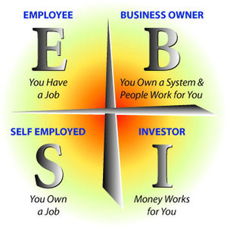

Time v. Value: What do each of these groups get paid on?
__________________________________________________________________________________________________________________________________________________________________________________________________________________________________________________________________________________________________________________________________________________________________________________________________________________________________________________________________________________________________________________________________________________________________________________________________________________________________________________________________________________________________________________________________________________________________________________________________________________________________________

STEPS TO FINANCIAL FREEDOM
THE PROCESS OF INVESTMENT

I. HOW TO BEGIN
______________________________________________________________________________________________________________________________________________________________________________________________________________________________________________________________________________

II. DEVELOP ASSET ALLOCATION
______________________________________________________________________________________________________________________________________________________________________________________________________________________________________________________________________________
______________________________________________________________________________________________________________________________________________________________________________________________________________________________________________________________________________

III. STEPS TO FINANCIAL FREEDOM
______________________________________________________________________________________________________________________________________________________________________________________________________________________________________________________________________________
______________________________________________________________________________________________________________________________________________________________________________________________________________________________________________________________________________
______________________________________________________________________________________________________________________________________________________________________________________________________________________________________________________________________________
__________________________________________________________________________________________

THE PSYCHOLOGY AND THE MEANING OF WEALTH
What does it mean to be wealthy? In other words, define wealth.
____________________________________________________________________________________________________________________________________________________________________________________________________________________________________________________________________________________________________________________________________________________________________________________________________________________________________________________________________________________________________________________________________________________________

THE DISTINCTION BETWEEN WEALTHAND FINANCE
Statistics on financial abundance and unhappiness.
________________________________________________________________________________________________________________________________________________________________________________________________________________________________________________________________________________________________________________________________________________________________________________________________________________________________________________________________________________________________________________________________________________________________________________________________________________________________________________________________________________________________________________________________________________
______________________________________________________________________________________________________________________________________________________________________________________________________________________________________________________________________________
______________________________________________________________________________________________________________________________________________________________________________________________________________________________________________________________________________

THE FIVE STEP PROCESS OF CREATING TRUE WEALTH AND HAPPINESS
I. WHO ARE YOU?
______________________________________________________________________________________________________________________________________________________________________________________________________________________________________________________________________________

II. WHAT DO YOU DO?
______________________________________________________________________________________________________________________________________________________________________________________________________________________________________________________________________________

III. WHY DO YOU DO WHAT YOU DO?
______________________________________________________________________________________________________________________________________________________________________________________________________________________________________________________________________________

IV. WHO DO YOU DO IT FOR?
______________________________________________________________________________________________________________________________________________________________________________________________________________________________________________________________________________

V. WHY DOES IT MATTER?
______________________________________________________________________________________________________________________________________________________________________________________________________________________________________________________________________________

III. BUILDING A LOVING AND LASTING RELATIONSHIPS
Three Reasons for Communication
I.________________________________________________________________________________________________________________________________________________________________________________________________________________
II._______________________________________________________________________________________________________________________________________________________________________________________________________________
III.____________________________________________________________________________________________________

The Ultimate Reason for Communication
__________________________________________________________________________________________________________________________________________________________________________________________________________________

In order for you to feel good, how should you communicate?
___________________________________________________________________________________________________________________________________________________________________________________________________________________________________________________________________________________________________________________________
RULES:
The Source of Pain or Pleasure
I. What are your personal standards? Pick one area such as health, finance or relationship and explain how you deal with yourself and others in that area.
__________________________________________________________________________________________________________________________________________________________________________________________________________________________________________
_______________________________________________________________
Four Steps of Rule Creation
I.______________________________________________________________________________________________________________________________________________________________________________
II._______________________________________________________________________________________
III.______________________________________________________________________________________
IV._________________________________________________________________________________________________________________________________________________________________________________
Emotional Fitness/Psychological Strength
What are Emotions?
__________________________________________________________________________________________________________________________________________________________________________________________________________________________________________

List all the emotions you feel on a weekly basis. Please put each emotion either on the positive or negative category.
______________________________________________________________________________________________________________________________________________________________________________________________________________________________________________________________________________________________________________________________________________________________________________________________________

Four Ways of dealing with Emotions
I. ____________________________________________________________________________
II.____________________________________________________________________________
III.___________________________________________________________________________
IV.______________________________________________________________________________________________________________________________________________________

Three Ways to Control our Emotions
I. ____________________________________________________________________________
II.____________________________________________________________________________
III.__________________________________________________________________________
Signs of Negative Emotions and How to Utilize them in an Empowering Manner
I. Fear _____________________________________________________________________________________________
_____________________________________________________________________________________________________
II. Hurt _______________________________________________________________________________________________
___________________________________________________________________________________________________
III. Anger ____________________________________________________________________________________________
_________________________________________________________________________________________________________
IV. Frustration_______________________________________________________________________________________
_________________________________________________________________________________________________________
V. Disappointment _________________________________________________________________________________
_________________________________________________________________________________________________________
VI. Guilt ______________________________________________________________________________________________
_____________________________________________________________________________________________________
VII. Overwhelm ___________________________________________________________________________________
_________________________________________________________________________________________________________
VIII. Alone _________________________________________________________________________________________
_________________________________________________________________________________________________________
IX. Inadequate_______________________________________________________________________________________
_________________________________________________________________________________________________________

Cultivating Empowering Emotions That Creates a life of Fulfillment
- Love and Warmth
- Appreciative and Gratitude
- Curiosity
- Excitement and Passion
- Determination
- Flexibility
- Confidence
- Cheerful
- Feeling Healthy
- Sense of Contribution
What allows people to realize these emotions on a daily basis?
___

THE FORMULA FOR LASTING HAPPINESS OR MISERY
What area of your life are you currently happy about? Why?
__________________________________________________________________________________________________________________________________________________________________________________________________________________________________________________________________________________________________________________________________________

What area are you not happy about? Why?
__________________________________________________________________________________________________________________________________________________________________________________________________________________________________________________________________________________________________________________________________________

The Formula for Happiness or Misery...
__________________________________________________________________________________________________________________________________________________________________________________________________________________________________________________________________________________________________________________________________________
__________________________________________________________________________________________________________________________________________________________________________________________________________________________________________________________________________________________________________________________________________
________________________________________________________________________________________________________________________________________________________________________________________________________________________________________________________________________
Your Model of the World
What are your beliefs about...
__________________________________________________________________________________________________________________________________________________________________________________________________________________________________________________________________________________________________________________________________________________________________________________________________________________________________________________________________________________________________________________________________________________________________________________________________________________________________________________________________________________________________________________________________________________________________________________________________________________________________________

What emotions support your model of the world?
____________________________________________________________________________________________________________________________________________________________________________________________________________________________________________________________________________________________________________________________________________________________________________________________________________________________________________________________________________________________________________________________________________________________________________________________________________________________________________________________________________________________________________________________________________________________________________________________________________________________________________________________________________________________________________________________________________________________________________________________________________________________________________________________________________________________________________________________________________________________________________________________________________________________________________________________________________________________________________

The choice we make in life ultimately determines our destiny
Rosa Park

HOW TO BUILD A TRUSTING RELATIONSHIP

1. What is trust?
_________________________________________________________________________________________________________
____________________________________________________________________________________________________________________________________________________________________________________________________________________________________________________________________________________________________________________________________________________________________________________________________________________________________

2. The creation of B.I.G to create and maintain a trusting relationship.
_________________________________________________________________________________________________________
____________________________________________________________________________________________________________________________________________________________________________________________________________________________________________________________________________________________________________________________________________________________________________________________________________________________________

Exercise:
How could the B.I.G model have helped in one of your past relationship?
_________________________________________________________________________________________________________
____________________________________________________________________________________________________________________________________________________________________________________________________________________________________________________________________________________________________________________________________________________________________________________________________________________________________
_________________________________________________________________________________________________________
_____________________________________________________________________________________________________________________________________________________________________________________________________________________________________________________________________________________________________________________________________________________________________________________________________________________________________________________________________________________________________________________________________________
____________________________________________________________________________________________________________________________________________________________________________________________________________________________________________________________________________________________________________________________________________________________________________________________________________________________________

EFFECTIVE COMMUNICATION TECHNIQUES
THREE STEPS OF ATTENTATIVELISTENING
I_____________________________________________________________________________
II.____________________________________________________________________________
III.___________________________________________________________________________

EXERCISE
Pick a partner, and practice the three keys of effective listening.
______________________________________________________________________________________________________________________________________________________________________________________________________________________________________________________________________________________________________________________________________________________________________________________________________________________________________________________________________________________________________________________________________________________________________________________________________________________________________________________
______________________________________________________________________________________________________________________________________________________________________________________________________________________________________________________________________________________________________________________________________________________________________________________________________________________________________________________________________________________________________________________________________________________________________________________________________________________________________________________________________________________________________________________________________________________________
_____________________________________________________________________________________________________________________________________________________________________________________________________________________________________________________________________________________________________________________________________________________________________________________________________________________________________________________________________________________________________________________________________________________________________________________________________________________________________________________

_________________________________________________________________________________________________________
_____________________________________________________________________________________________________________________________________________________________________________________________________________________________________________________________________________________________________________________________________________________________________________________________________________________________________________________________________________________________________________________________________________________________________________________________________________________________________________________
THE POWER OF EFFECTIVE SPEAKING
1. What does it mean for someone to be considered an effective speaker?
_________________________________________________________________________________________________________
____________________________________________________________________________________________________________________________________________________________________________________________________________________________________________________________________________________________________________________________________________________________________________________________________________________________________
_________________________________________________________________________________________________________
__________________________________________________________________________________________________________________________________________________________________________________________________________________

How do you know whether someone is being authentic?
_________________________________________________________________________________________________________
____________________________________________________________________________________________________________________________________________________________________________________________________________________________________________________________________________________________________________________________________________________________________________________________________________________________________

Four Steps of Becoming an Authentic and Effective Speaker
_________________________________________________________________________________________________________
____________________________________________________________________________________________________________________________________________________________________________________________________________________________________________________________________________________________________________________________________________________________________________________________________________________________________
_________________________________________________________________________________________________________
_____________________________________________________________________________________________________________________________________________________________________________________________________________________________________________________________________________________________________________________________________________________________________________________________________________________________________________________________________________________________________________________________________________
___________________________________________________________________________________________________________________________________________________________________________________________________________________________________________________________________________________________________________________________
IV.UNDERSTANDING LEADERSHIP AND INFLUENCE

What is leadership? Who is a leader?
______________________________________________________________________________________________________________________________________________________________________________________________________________________________________________________________________________
What is influence? What are some ways of influencing others?
______________________________________________________________________________________________________________________________________________________________________________________________________________________________________________________________________________
Are you a leader? If yes, how do you know? If no, what do you need to become a leader?
UNDERSTANDING LEADERSHIP
JOHN MAXWELL'S FIVE LEVELS OF LEADERSHIP
I.________________________________________________________________________________________
MEANING______________________________________________________________________________________________________________________________________________________________________________________________________

II._______________________________________________________________________________________
MEANING______________________________________________________________________________________________________________________________________________________________________________________________________

III.______________________________________________________________________________________
MEANING______________________________________________________________________________________________________________________________________________________________________________________________________

IV.______________________________________________________________________________________
MEANING__________________________________________________________________________________________________________________________________________________________________________________________________________________________________________________________________

V._______________________________________________________________________________________
MEANING______________________________________________________________________________________________________________________________________________________________________________________________________

What level of leadership do you belong? Why do you think you belong under this category?
________________________________________________________________________________________________________________________________________________________________________________________________________________________________________________________________________________________________________________________________________________________________________

Which level would want to be strive towards in the next 12 months?
______________________________________________________________________________________________________________________________________________________________________________________________________________________________________________________________________________

In thinking about what we learned about effective communication, what concrete skills would you need to develop to achieve this goal?
________________________________________________________________________________________________________________________________________________________________________________________________________________________________________________________________________________________________________________________________________________________________________

In five years, what type of leader would you want to be? Again, what steps would you need to towards this goal?
____________________________________________________________________________________________________________________________________________________________________________________________________________________________________________________________________________________________________________________________________________________________________________________________________________________________________________________________________________________________________________________________________________________________________________________________________________________________________________________________________________________________________________________________________________________________________________________________________________________________________________________________________________________________________________________________________
THE POWER OF INFLUENCE
FIVE STEPS TO INFLUENCING OTHERS IN YOUR WAY OF THINKING

I. ________________________________________________________________________________________
____________________________________________________________________________________________________________________________________________________________________________________

II. _______________________________________________________________________________________
____________________________________________________________________________________________________________________________________________________________________________________

III. ______________________________________________________________________________________
____________________________________________________________________________________________________________________________________________________________________________________

IV. _____________________________________________________________________________________
___________________________________________________________________________________________________________________________________________________________________________________

V. _______________________________________________________________________________________
_______________________________________________________________________________________________________________________________________________________________________________________________________________________________________________________________________________________________________________________________________________________________________________________________________________________________________________________________________________________________________________________________________________________________________________________________________________________________________________________________________________________________________________________________________________

If you can influence people, you can lead them. If you cannot, then you're a manager.
THE MEANING OF GREAT LEADERSHIP
WHAT DO GREAT LEADERS DO?

I. When you failed to achieve something significant, why did you fail to achieve ? List all the reasons why you think you failed.
_____________________________________________________________________________________________________________________________________________________________________________________________________________________________________________________________________________________________________________________________________________________________________________________________________

HOW GREAT LEADERS DEAL WITH FAILURE
EMOTIONS THAT MAXIMIZES HUMAN RESOURCES
____________________________________________________________________________________________________________________________________________________________________________________________________________________________________________________________________________________________________________________________________________________________________________________________________________________________________________________________________________________________________________________________________________________________________________________________________________________________________________________________________________________________________________________________________________________________________________________________________________________________________________________________________________________________________________________________________________________________________________________________________________________________________________________________________________________________________________________________________________________________________________________________________________________________________________________________________________________________________________

LEADERS VS. MANAGERS

I. Begins with a praise and honest appreciation.

2. Calls attention to people's mistakes indirectly.

III. Talks about their own mistake first before criticizing the other person.

IV. Asks questions instead of giving direct orders.

V. Praises the slightest improvement and praises every improvement

VI. Gives the other person a fine reputation to live up to.

I. Blames others whenever there is a problem.

II. Directly pointing out the person's mistake.

III. Talks about the faults of others and directly criticizing.

IV. Constantly giving direct orders without asking the opinion of others.

V. Only praises the major improvements.

VI. Focuses more on what's wrong rather than lifting people's spirit.

What is the difference between a manager and a leader?
______________________________________________________________________________________________________________________________________________________________________________________________________________________________________________________________________________

THE DISTINCTION BETWEEN A MANAGER AND A LEADER
I_________________________________________________________________________________________________________________
II._______________________________________________________________________________________________________________

WHAT IS LEADERSHIP?
I._____________________________________________________________________________
II.__________________________________________________________________________________________________________________________________________________________

{Leadership is the art of getting extraordinary performance from ordinary people}
Anonymous

LEADERSHIP WITHOUT A TITLE
Do you impact the quality of people's experience?
Do your presence allows others to strive to be better?
Do you work well with others in achieving a specific objective?
Are you in control of your life?
Do you make a difference in your career or business?

If you answer yes to any of these questions, you are leader, even though you might not have a title.

HISTORIC EXAMPLES OF LEADERS WITHOUT A TITLE

The Rag-tag militias of the American Revolution led to the transformation of the world. When 60 individuals stood in Lexington on that fateful day in 1776 against 900 of the most powerful army in the world, little did they know that their courage will birth a nation unlike any in the history of the world. While we'll never know the names of those courageous individuals, their leadership legacy will forever live-on.

If Rosa Park waited for a title on December 1st, 1955, we might not be realizing some of the things we take for granted today. While Rosa Park did not have a title at the time, she had something much better than a title: A desire to live in an equal and just society. Thus, her actions ended up changing our society and culture.

When a child stood in front of a tank in Tenement Square in 1989, most of the world did not know his name, and most people will never know his name at all. While most will never know his name, his actions led to freedom for millions of Chinese citizens.

What does the American Revolutionaries, Rosa Parks and the Chinese Activist have in common? What they have in common is what allows anyone regardless of your situation to positively change society: Vision, Desire and Courage.

THREE KEYS OF LEADERSHIP
I______________________________________________________________
II_____________________________________________________________
III____________________________________________________________

{An army of deer led by a lion is more to be feared than an army of lions led by a deer}
Phillip of Macedonia

s

PERSONAL MISSION STATEMENT
Write a clear, compelling personal mission statement. Always begin with WHY? Who do you want to be in this world? What would you want to be known for? How would the world be different because you were born?
____________________________________________________________________________________________________________________________________________________________________________________________________________________________________________________________________________________________________________________________________________________________________________________________________________________________________________________________________________________________________________________________________________________________
____________________________________________________________________________________________________________________________________________________________________________________________________________________________________________________________________________________________________________________________________________________________________________________________________________________________________________________________________________________________________________________________________________________________
____________________________________________________________________________________________________________________________________________________________________________________________________________________________________________________________________________________________________________________________________________________________________________________________________________________________________________________________________________________________________________________________________________________________
__________________________________________________________________________________________________________________________________________________________________________________________________________________________________________________________________________________________________________________________________________________________________________________________________________________________________________________________________________________________________________________________________________________________________________________________________________________________________________________________________________________________________________________________________________________________________________________________________________________________________________________________________________________________________________________________________
THE SECRET TO WEALTH IS GRATITUDE
WHAT ARE YOU GRATEFUL FOR IN LIFE?
______________________________________________________________________________________________________________________________________________________________________________________________________________________________________________________________________________
______________________________________________________________________________________________________________________________________________________________________________________________________________________________________________________________________________
______________________________________________________________________________________________________________________________________________________________________________________________________________________________________________________________________________
______________________________________________________________________________________________________________________________________________________________________________________________________________________________________________________________________________
______________________________________________________________________________________________________________________________________________________________________________________________________________________________________________________________________________
______________________________________________________________________________________________________________________________________________________________________________________________________________________________________________________________________________
______________________________________________________________________________________________________________________________________________________________________________________________________________________________________________________________________________
______________________________________________________________________________________________________________________________________________________________________________________________________________________________________________________________________________
__________________________________________________________________________________________________________________________________________________________________________________________________________________________________________________________________________________________________________________________________________________________________________________________________________________________________________________________________
Reference Page
Gladwell, Michael. Outliers: Stories of Success
Brown Brene, Daring Greatly
Brown Brene, Rising Strong
Robbins, Tony. Awaken the Giant Within
Robbins, Tony. Money Master the Game
Kiyosaki, Robert. Rich Dad, Poor Dad
Maxwell, John C. 21 Laws of Leadership
Sharma, Robin. A Leader Without a Title
Sanborn, Mark. You Don't need a Title to become a Leader
Sinek Simon. "Starting With a Why." TED Talk.
Covey Stephen. 7 Habits of Highly Effective People
Carnegie, Dale. How to Win Friends and Influence People
Hill, Napoleon. Think and Grow Rich
Allen, James. As a Man Thinketh
Dyer, Wayne. your Erroneous Zones
Dyer, Wayne. The Power of Intention
Eker, Harv T. Secrets of Millionaire mind
Newport, Carl. So Good They Can't Ignore You
Cialdini, Robert. Influence
Newport, Carl. How to Become a Straight A Student
Tracy, Brian. Eat That Frog
Roosevelt, Eleanor. You Learn by living
Harris Russ. The Confidence Gap
Lopez, Shane. Making Hope Happen
Rohn, Jim. Philosophies of Successful living
Buchard, Brendon. The Motivation Manifesto
Krech, Gregg. The Art of Taking Action
Greene, Robert. Mastery
Guillerbeau, Chris, Born for This
Kleon, Austin. Show Your Work

