Social Identity Wheel

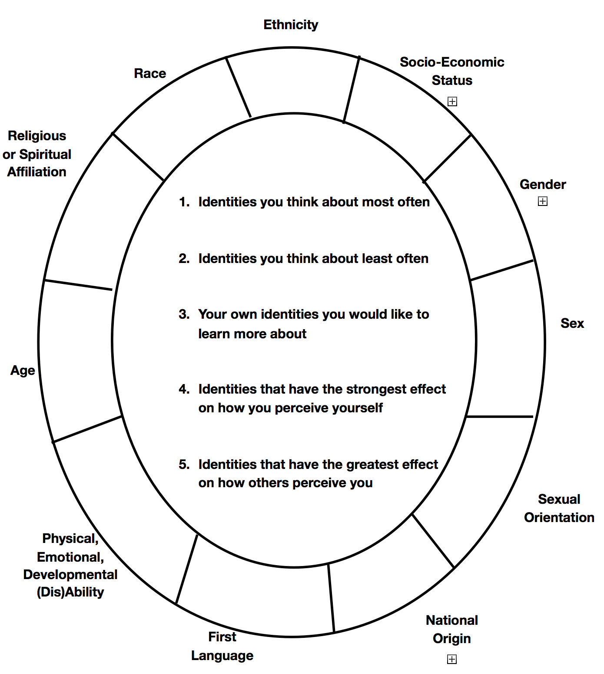

Social Identity Wheel

The Social Identity Wheel worksheet is an activity that encourages students to identify and reflect on the various ways they identify socially, how those identities become visible or more keenly felt at different times, and how those identities impact the ways others perceive or treat them. The worksheet prompts students to fill in various social identities (such as race, gender, sex, ability disability, sexual orientation, etc.) and further categorize those identities based on which matter most in their self-perception and which matter most in others’ perception of them.

