PEACEFUL COYOTES
A guide for awareness, peace and social-emotional development in school communities.

Good health and academic success go hand in hand.
- Health Education content standards for California public schools

March Weeks 3 & 4: Making Amends
Objective:
- To understand that by making amends with someone who you have hurt you are helping yourself to be more at peace.
- To learn how to make amends by correcting a mistake that one has made or fixing a bad situation.

Inspirational Quotes:
“Anyone can make a mistake and run away from it, but it takes a special kind of person to make a mistake, admit to it and face the pain and trouble that may come with making amends. Hang on to those people. You will never have to heal alone.” –Unknown.

"It's not a person's mistakes which define them - it's the way they make amends." –Freya North

“Without acknowledging behavior, I’m sorry is just avoiding the truth of what really happened.” -Unknown

“There is a great difference between apologizing and making amends.” Abeautifulmessinside.com

“Every passing minute is a chance to turn it all around” –Unknown

“Be sure to taste your words before you spit them out.” –Unknown

Assignment:
These next couple weeks we are focusing on Making Amends. How is that different than saying you are sorry, you might wonder?
In your gratitude journal:

Write a list of persons you need to make amends with. It could be from a time you were unkind to someone or hurt someone’s feelings or maybe you actually physically hurt them on accident or on purpose. It could be a family member or friend. Here are some tips to try out for making amends. Give it a try and share in council how it went.

1. Acknowledge your role. The first step toward repairing relationships is taking responsibility for your role in the problem. Without expecting anything in return, such as forgiveness, friendship or acceptance.
2. After you acknowledge that you've made mistakes or caused hurt, apologize for doing so.
3. Make it right… if possible.
4. Lastly, change your behavior after you recognize it is causing hurt, harm or pain to someone. You can regain trust through actions not word.
Literature:
Enemy Pie by Derek Munson

The Big Red Lollipop by Rukhsana Khan

A Day’s Work by Eve Bunting

The Honest-to-Goodness Truth by Patricia C. McKissack and Giselle Potter

Let’s Be Enemies by Janice May Udry

The Summer My Father Was Ten by Pat Brisoon

The Dragon was Terrible by Kelly DiPucchio

Train Your Angry Dragon by Steve Herman

Train Your Dragon to Be Responsible by Steve Herman

Horrible Bear by Ame

Stick and Stone by Beth Ferry
Crappy Pants by Julie Gassman

Lying Up a Storm by Julia Cook

Rude Cakes by Rowboat Watkins

Forgive and Let Go by Cheri J. Meiners

Music:
I Can See Clearly Now by Johnny Nash
https://www.youtube.com/watch?v=FscIgtDJFXg

Sorry Seems to Be the Hardest Word by Elton John
https://www.youtube.com/watch?v=c3nScN89Klo

Redemption Song by Bob Marley

Three Little Birds by Bob Marley

Respect by Aretha Franklin

Respect Yourself by Staples Singers

“All You Need is Love” by the Beatles
“Love is the Answer” by Aloe Blacc
“Heart of the Matter” by Don Henley

Art Activity:
Use art to have student show what they think making amends looks like. Like an advertisement for “making amends.

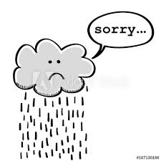

Create a comic strip of how a character make amends with a friend after hurting them.

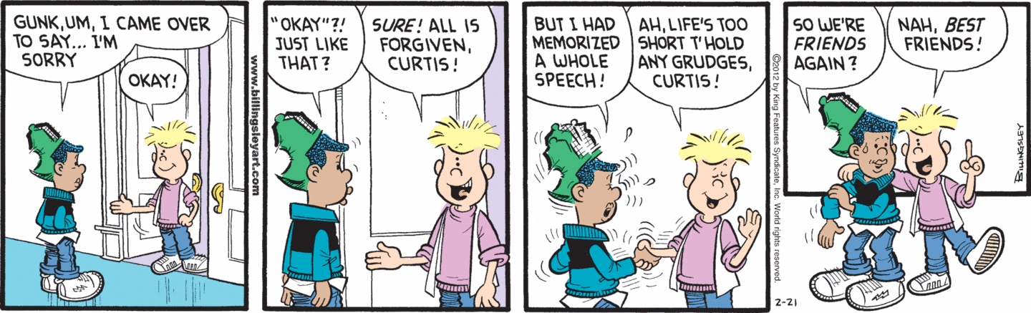

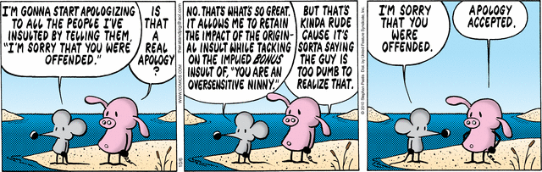

Activities:
Morning Meeting Share
Using chart paper or in a classroom share, pose this question: How is apologizing and making amends different… Give an example of a time you had to make amends (meaning fixing a problem you caused or contributed to). Students may write on post it and post of chart how making amends is different than apologizing or give any example of how or when they had to make amends.

Repairing Friendship Meditation Activity
Adapted from Mindful Kids: 50 Mindfulness Activities for Kindness, Focus, and Calm

- Sit Mindfully with your spine straight and body relaxed. Close your eyes. Take 3 soft, slow, mindful breaths. When you breathe in think “in” and when you breathe out think “out.”
- Think of a friend or person that you may have hurt or made mad.
- Imagine your feelings for that person as gold rays of light filling up in your heart as you breathe. Breathe in and out and imagine sending the golden light rays to a friend who needs some kindness. See you friend receiving the golden light ray of friendship and smiling.
- Now with your next breath out, send your golden light rays of friendship to someone you don’t know very well. See that person receiving the golden light ray of friendship and smiling.
- Now with your next breath out, and share your golden rays with someone you feel grumpy or unhappy with. Watch how your kindness helps that person to smile.
- Finally share your gold light with everyone in the world. Imagine people in the world smiling together and know your smile helps contribute to peace.
- Smile with that happy feeling. Take the last three soft, slow mindful breaths before you open your eyes.

Writing Activity:
Write a letter to someone you need to make amends with.

2 Way of Council Prompts (one for each week, they build)

Open with Dedications

Speed round: If you did the charting of the difference between making amends and apologizing you can refer to it for this round or use this time to have the children share: How is apologizing and making amends different? When do we make amends instead of just apologizing?

Round 1: Think about a time when you might have hurt someone or done something wrong to someone. Show me with your thumb on your chest when the memory has come to you. Now think about something you could do to set things right. We will pass the talking piece where you can share if it is appropriate how you can “right a wrong.”

Witness Round: Share a word, phrase, idea or sentiment that sticks in your mind or heart today?

Closing of Choice.

Next Week’s Council Prompt:

Opening: This week we are reflecting on what it feels like to make amends rather than just apologizing. Think back to a conversation you had with someone when trying to make amends. Was it easy, difficult, maybe even scary? Perhaps your heart started beating rapidly. How did that person react? And how did you feel after it was over? Today we will share the different ways we have made amends with someone by correcting a mistake that one has made or fixing a bad situation and how that felt.

Dedications: (Children share who or what they would like to dedicate this time to)

Speed round: Why is making amends important?

Storytelling Round: Think for a moment about a time someone was mad or hurt by something you did or said. How did you fix it? Did they forgive you right away or did it take time? How did you earn their trust back? If you can tell about a time you had or needed to make amends and how that went. Reflect on what feelings came up for you.

Witness Round:
Share a word, phrase, idea or sentiment that sticks in your mind or heart today.

Closing:
Allow a student to choose a closing.

