**PEER CONFERENCE NOTES**

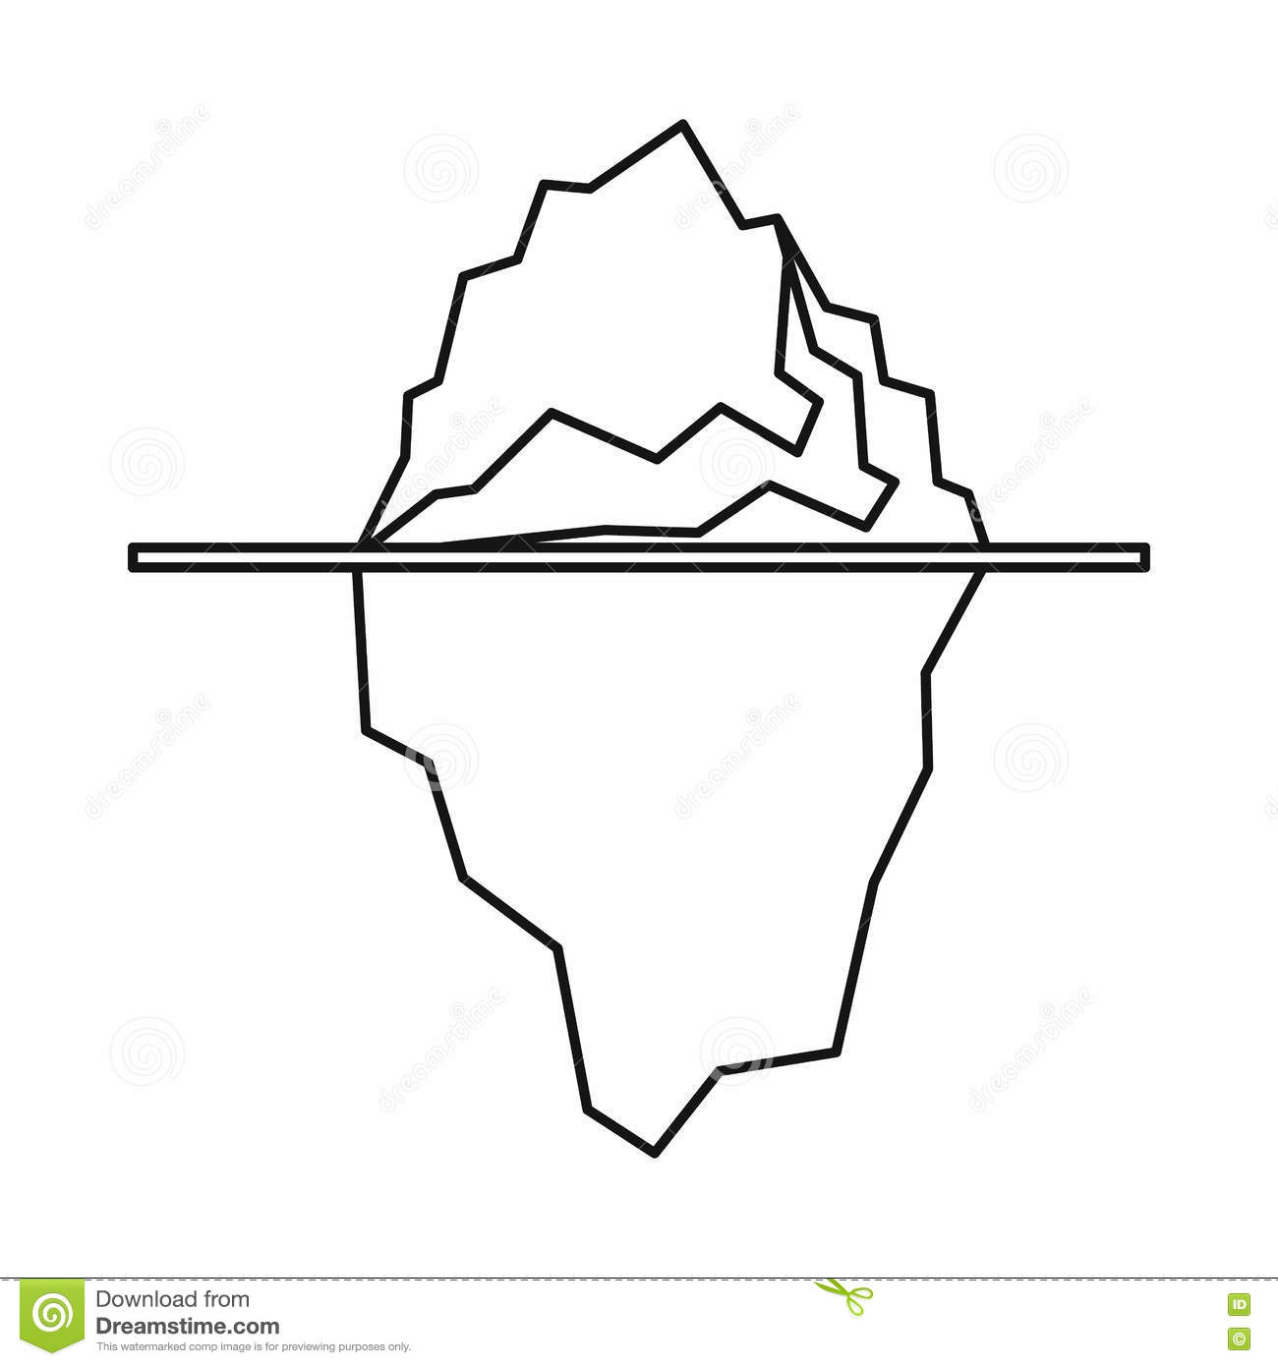Referred student:___________________________________________ Date:________________

**What Happened:**

**Root Causes:**

**Impact:**



**Agreement:**